**Install Kubernetes Cluster on AWS(Ubuntu 20.04) with kubeadm**

**Master**: A Kubernetes Master is where control API calls for the pods, replications controllers, services, nodes and other components of a Kubernetes cluster are executed.

**Node**: A Node is a system that provides the run-time environments for the containers. A set of container pods can span multiple nodes.

**Prerequisites:**

* 2 or 3 Ubuntu 20.04 LTS System with Minimal Installation
* Minimum 2 or more CPU, 3 GB RAM [Only for Master]
* Disable SWAP on All node
* SSH Access with sudo privileges
  + Internet connectivity for pulling containers required (Private registry can also be used)
  + Full network connectivity between machines in the cluster – This is private or public

**AWS Instance Creation for Master & Slave:**

* Login to AWS account and create EC2 instance[KubeMaster] for Kubernetes Master node which should be minimum of t2.medium.
* Create 2 more EC2 instances[KubeWork1,KubeWork2] for worked nodes with t2.micro instance.



**Firewall Ports/Inbound Traffic Ports for Kubernetes Cluster**

**Master Node :**

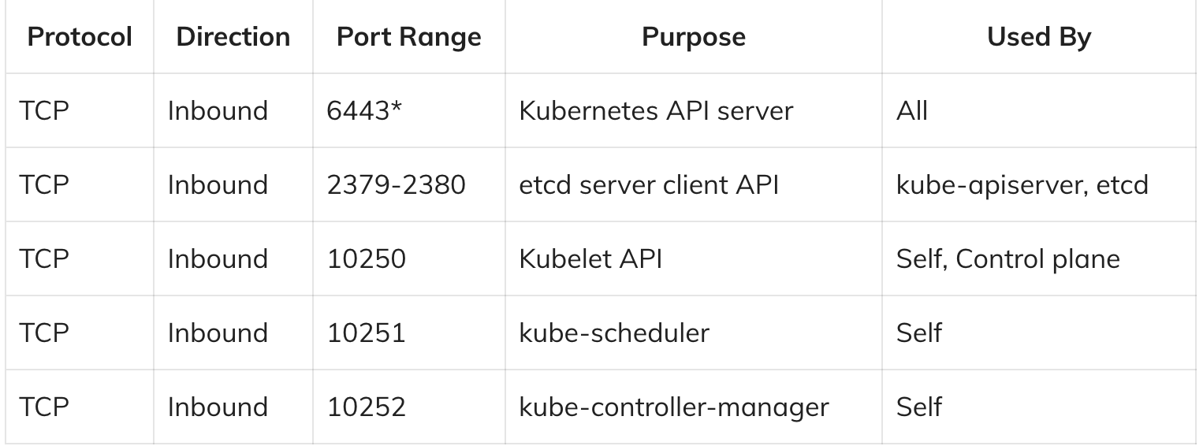

**Slave Node(s) :**

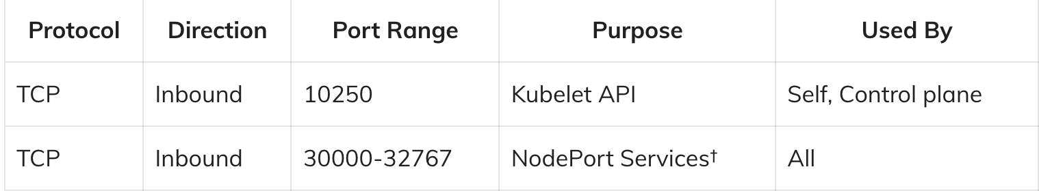

**SSH to Master & Worker Instances :**

Make sure you have configured AWS CLI and then SSH to Master and Worked EC2 instances from 2 different terminal’s

**Disable Swap and Reboot the instances in both Master & Slave Node :**

Disable swap

swapoff -a

Reboot

sudo reboot

Update the system Packages

sudo apt-get update

**Step-1 :Install Docker Container Runtime on All node (Master and Worker Nodes)**

Install below packages if not installed

sudo apt-get install -y \

apt-transport-https \

ca-certificates \

curl \

gnupg \

lsb-release

Add the Docker official GPG Key

curl -fsSL https://download.docker.com/linux/ubuntu/gpg | sudo gpg --dearmor -o /usr/share/keyrings/docker-archive-keyring.gpg

Add the Docker APT repository

echo "deb [arch=amd64 signed-by=/usr/share/keyrings/docker-archive-keyring.gpg] https://download.docker.com/linux/ubuntu \

$(lsb_release -cs) stable" | sudo tee /etc/apt/sources.list.d/docker.list > /dev/null

Update the System Packages

sudo apt-get update -y

Install docker community edition and container runtime on both master and worker node

sudo apt-get install docker-ce docker-ce-cli containerd.io -y

Add the Docker Daemon configurations to use systemd as the cgroup driver.

cat <<EOF | sudo tee /etc/docker/daemon.json

{

"exec-opts": ["native.cgroupdriver=systemd"],

"log-driver": "json-file",

"log-opts": {

"max-size": "100m"

},

"storage-driver": "overlay2"

}

EOF’

Check docker images

docker images

Start the Docker service if not started

sudo systemctl start docker.service

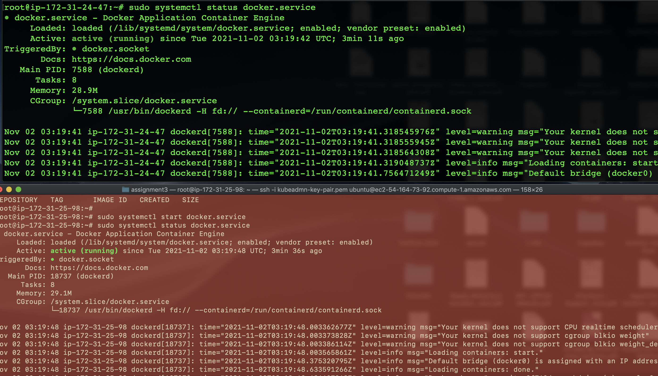

To check the docker service status

sudo systemctl status docker.service

Enable Docker service at startup

sudo systemctl enable docker.service

Restart the Docker service

sudo systemctl restart docker

Enable Https Service on all nodes

sudo apt-get install -y apt-transport-https

Install Curl on All Nodes

sudo apt-get install -y apt-transport-https

## **Step-2. Add Kubernetes GPG Key on All node**

Add Kubernetes GPG key in all node.

sudo curl -fsSLo /usr/share/keyrings/kubernetes-archive-keyring.gpg https://packages.cloud.google.com/apt/doc/apt-key.gpg

## **Step-3. Add Kubernetes APT Repository on All node**

Add Kubernetes apt repository on all node for Ubuntu.

sudo apt-add-repository "deb http://apt.kubernetes.io/ kubernetes-xenial main"

echo "deb [signed-by=/usr/share/keyrings/kubernetes-archive-keyring.gpg] https://apt.kubernetes.io/ kubernetes-xenial main" | sudo tee /etc/apt/sources.list.d/kubernetes.list'

update the system packages

sudo apt-get update

## **Step 4. Install Kubeadm,Kubelet and Kubectl on All Node**

Install kubeadm,kubelet and kubectl using below command.

sudo apt-get install -y kubelet kubeadm kubectl

Hold the packages to being upgrade

sudo apt-mark hold kubelet kubeadm kubectl

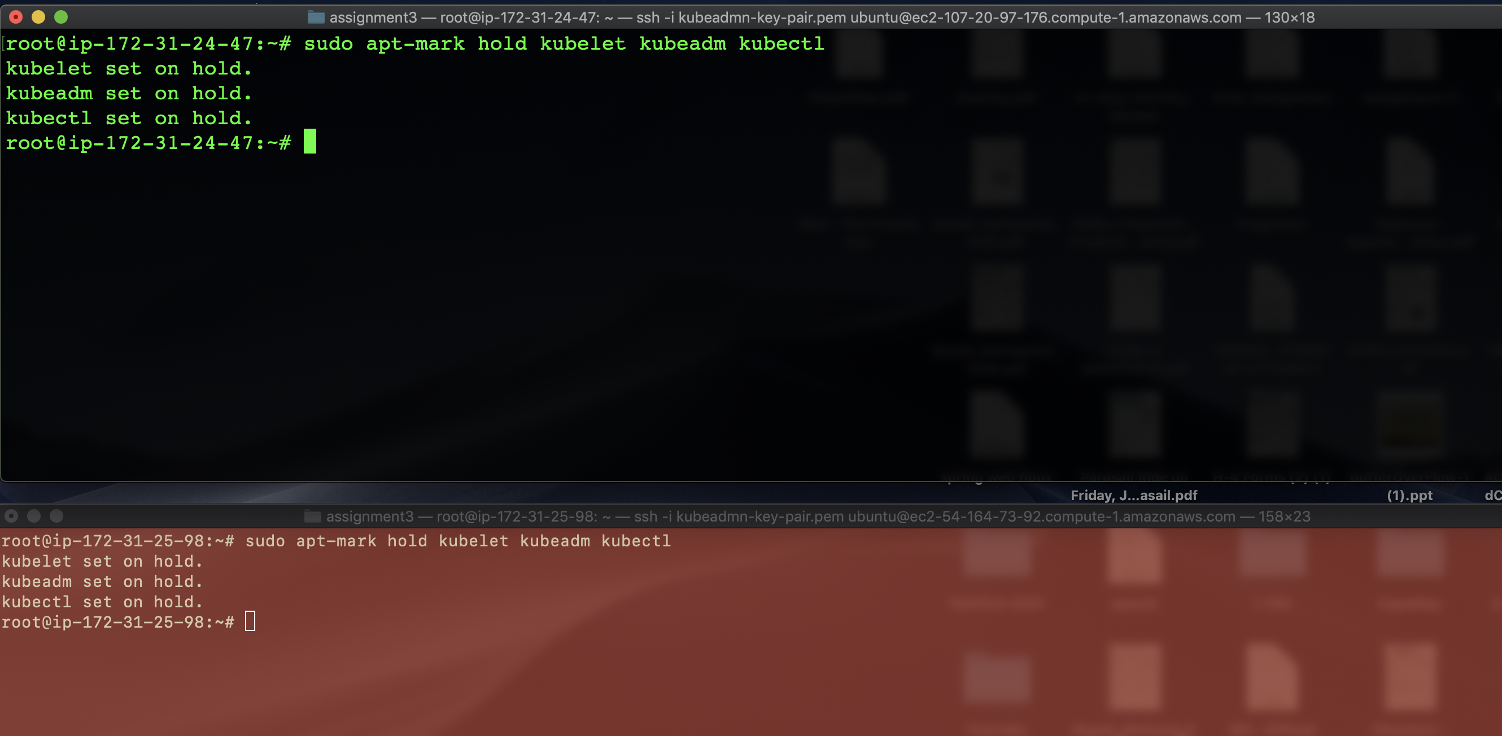

Check the version

kubectl version --client && kubeadm version

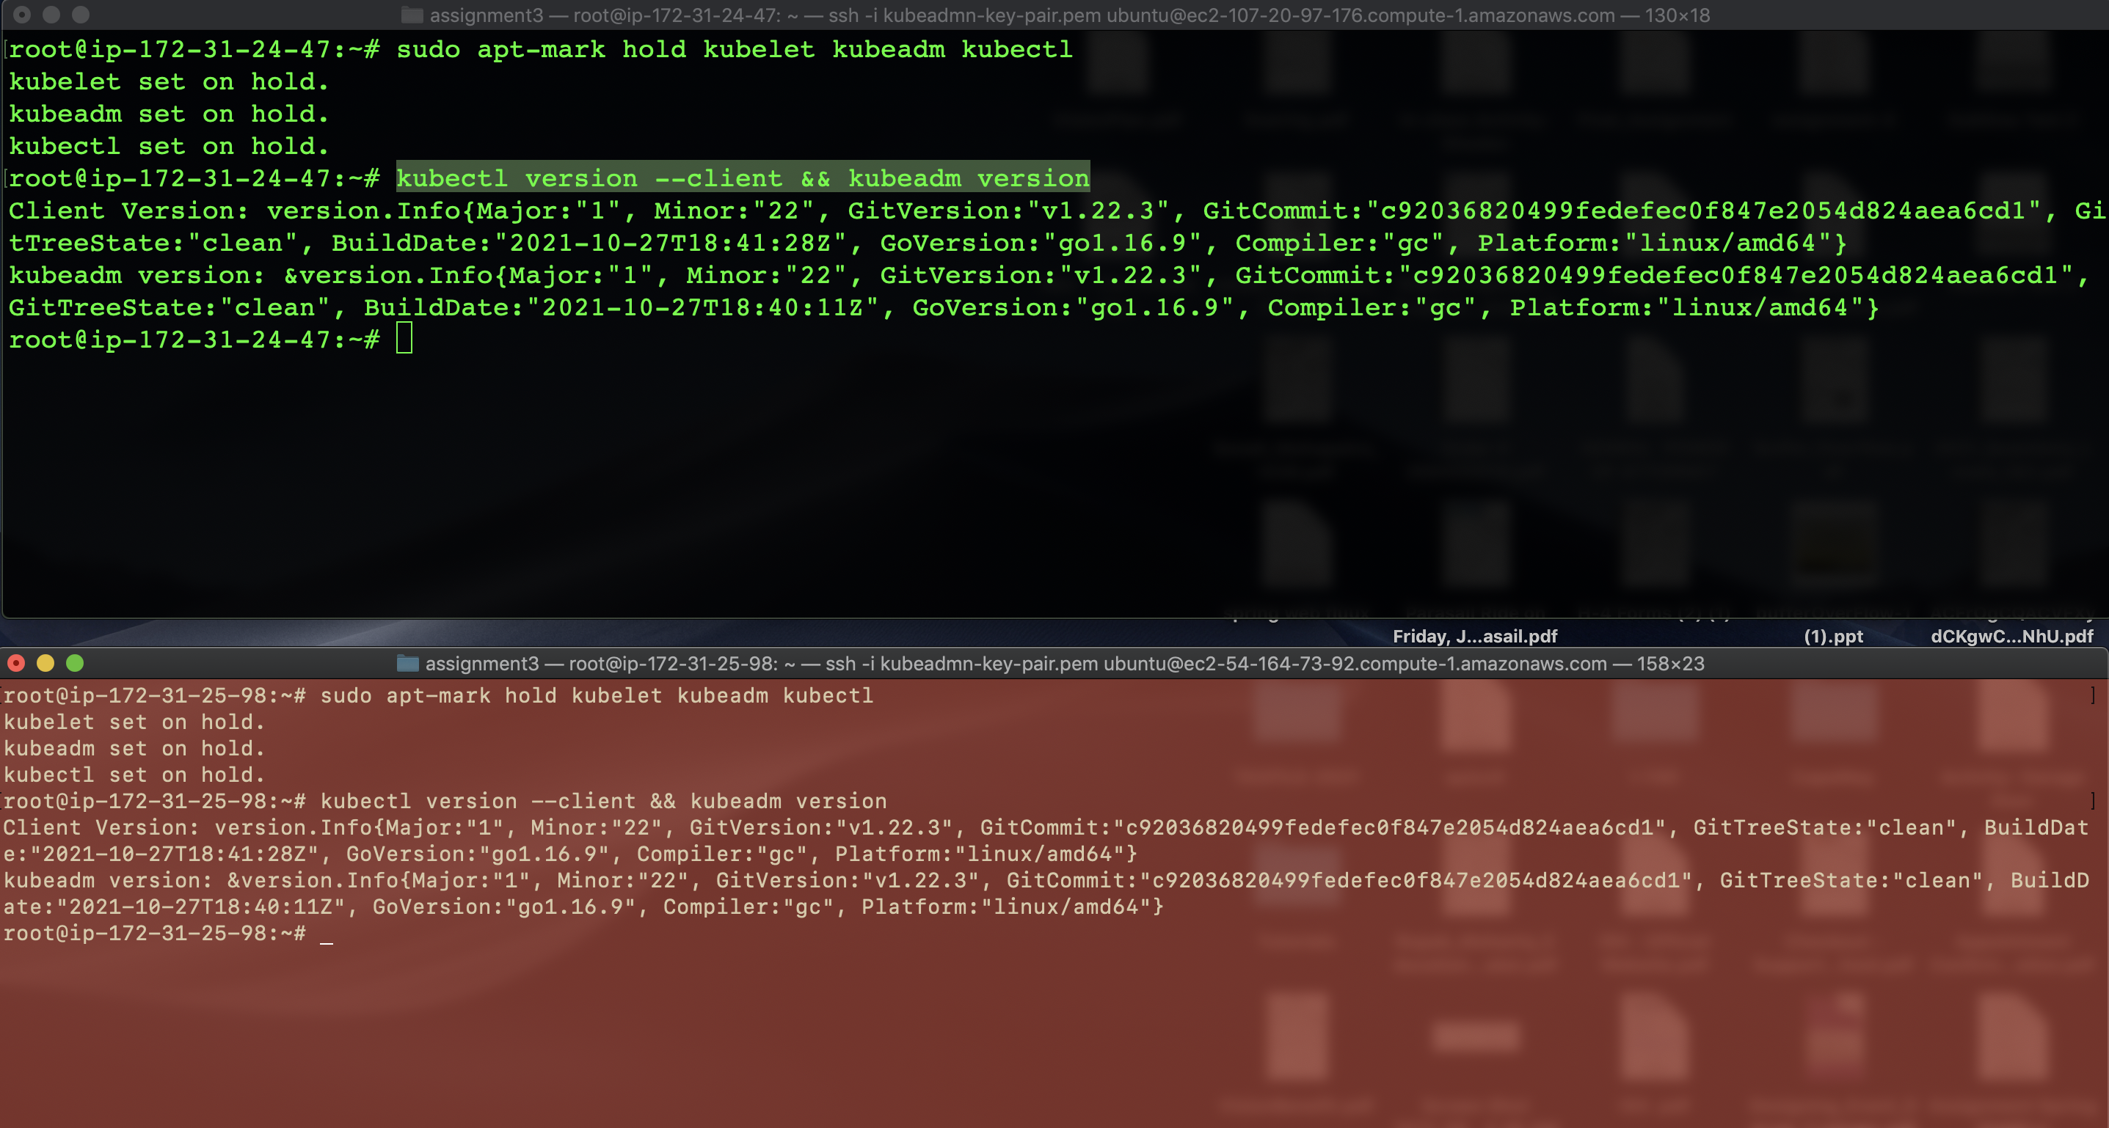

**Step 5. Configure cggroup driver, add the cggroup driver in kubelet for both the nodes**

Add the cggroup driver for new version of Kubernetes

sudo sed -i "s/cgroup-driver=systemd/cgroup-driver=cgroupfs/g" /etc/systemd/system/kubelet.service.d/10-kubeadm.conf

Reload the daemon

sudo systemctl daemon-reload

Restart the kubelet service

sudo systemctl restart kubelet

**Step 6. Initialize the Master node using kubeadm (on Master Node)**

Next initialize the master node using kubeadm.

sudo kubeadm init --pod-network-cidr 192.168.10.0/24

output

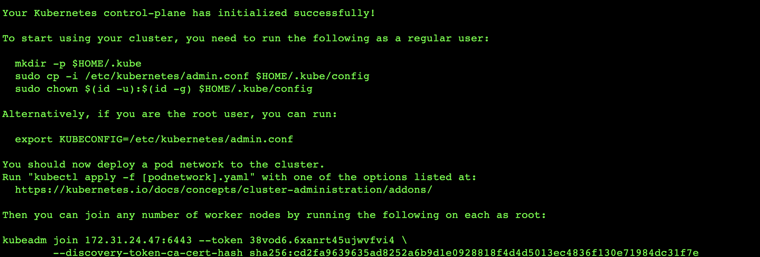

As above output mentioned copy the token in your notepad, we will need to join worker/slave to master node

Create new ‘.kube’ configuration directory and copy the configuration ‘admin.conf’ from ‘/etc/kubernetes’ directory.

mkdir -p $HOME/.kube

sudo cp -i /etc/kubernetes/admin.conf $HOME/.kube/config

sudo chown $(id -u):$(id -g) $HOME/.kube/config

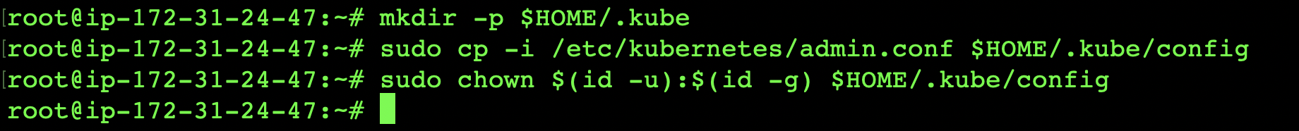

To check kubeadm version.



To check master node status

kubectl get nodes



Step 7.Configure Pod Network and Verify Pod namespaces(Master Node)

Install the Weave network plugin to communicate master and worker nodes.

kubectl apply -f "https://cloud.weave.works/k8s/net?k8s-version=$(kubectl version | base64 | tr -d '\n')"

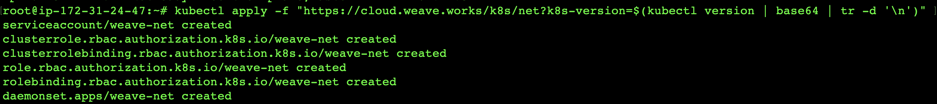

### Step-8. Join Worker Node to the Cluster [on Worker Node]

Next Join two worker nodes to master.

kubeadm join 172.31.24.47:6443 --token 38vod6.6xanrt45ujwvfvi4 \

--discovery-token-ca-cert-hash sha256:cd2fa9639635ad8252a6b9d1e0928818f4d4d5013ec4836f130e71984dc31f7e

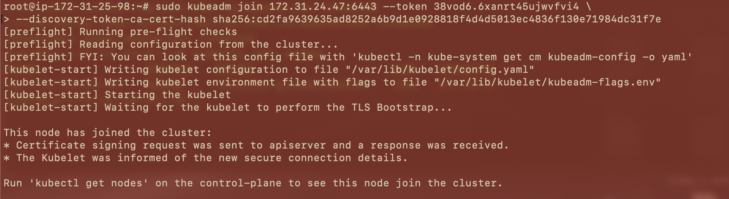

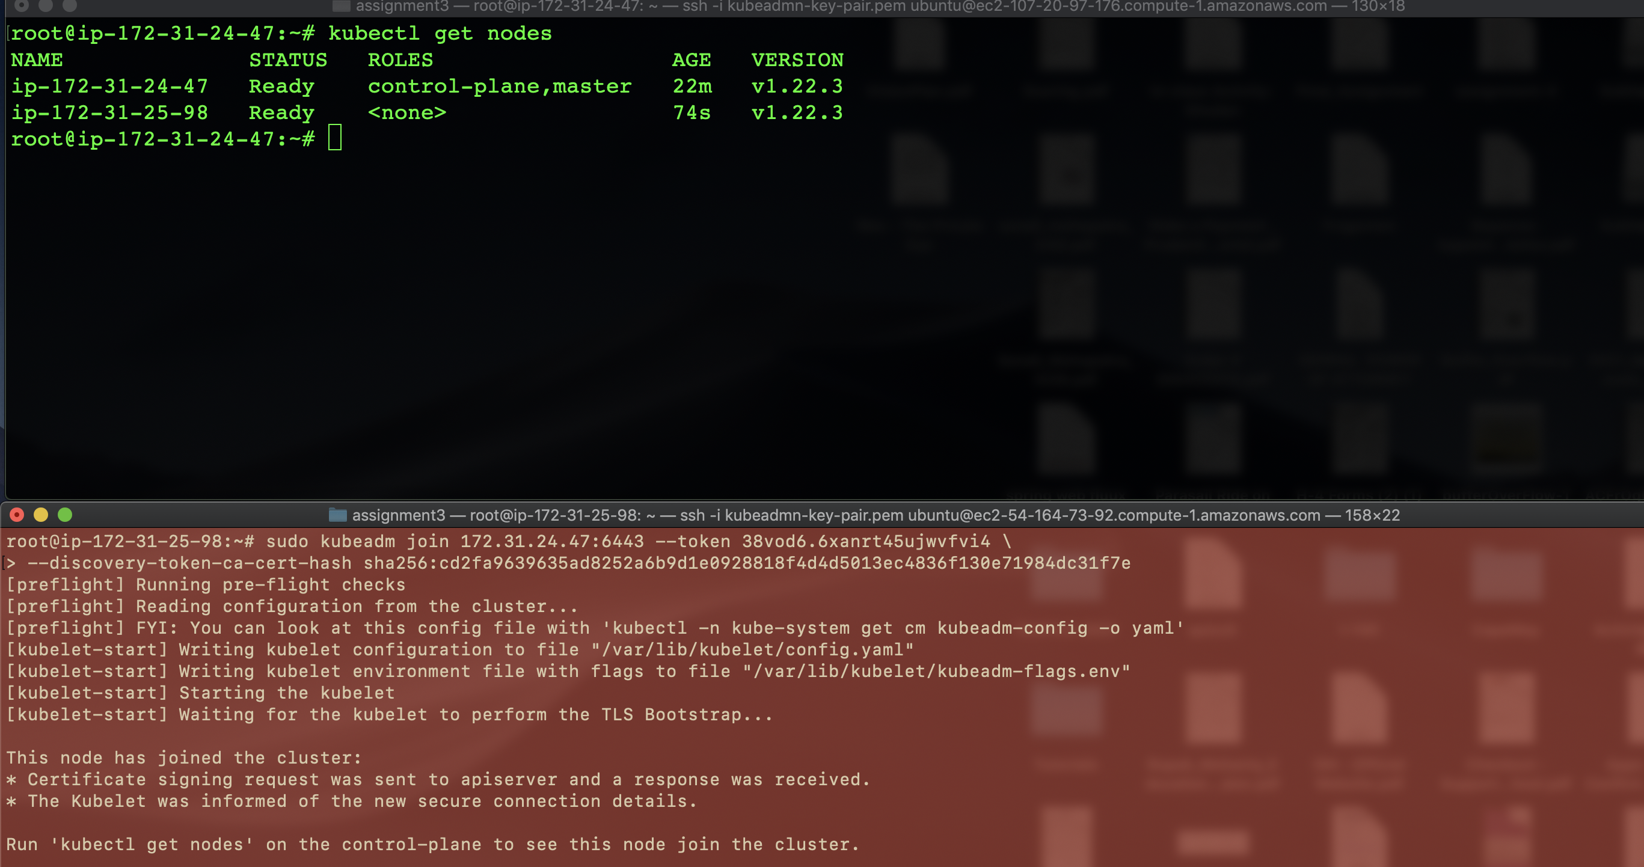

Lets level the node using the below command on master node

kubectl label node <worked ip address>node-role.kubernetes.io/worker=worker

kubectl label node ip-172-31-25-98 node-role.kubernetes.io/worker=worker

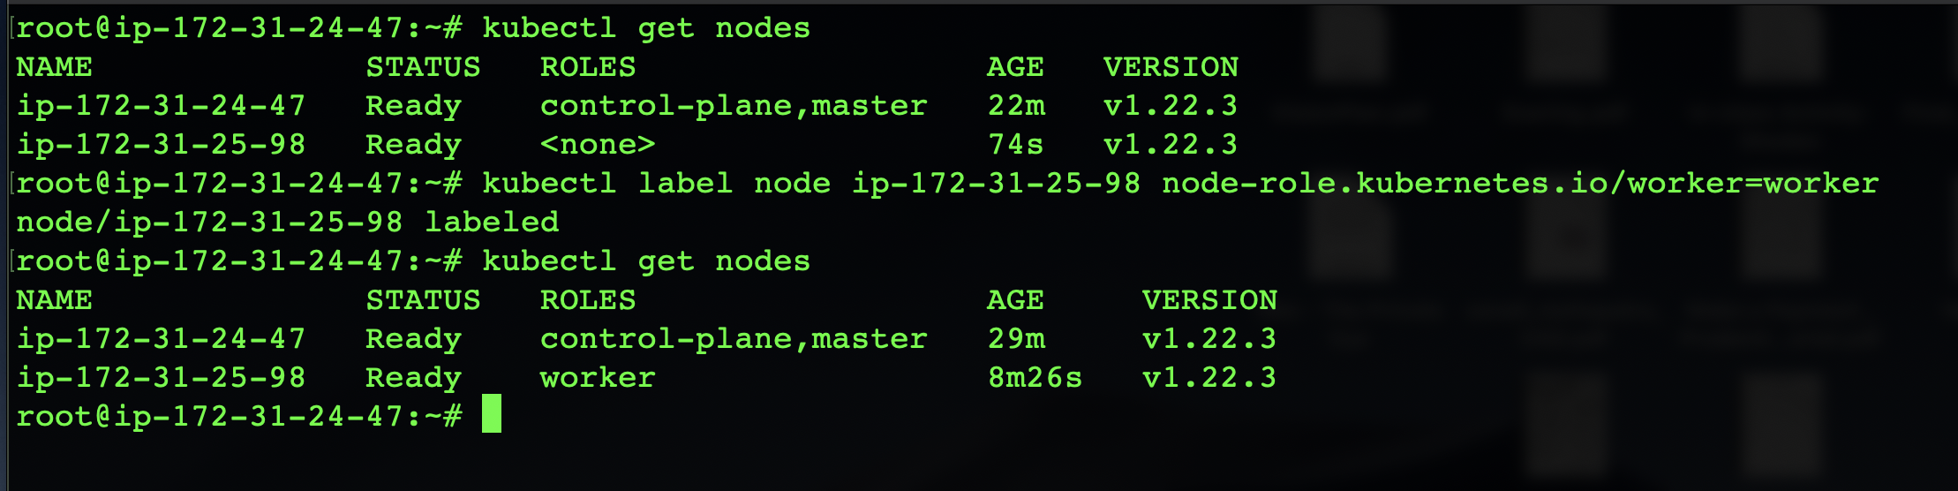

### Step-9. Deploying Sample Microservice On Kubernetes Cluster[Master Nodes]

Lets create a deployment on master node named “nginx-deploy” using YAML.

sudo nano nginx-deploy.yaml

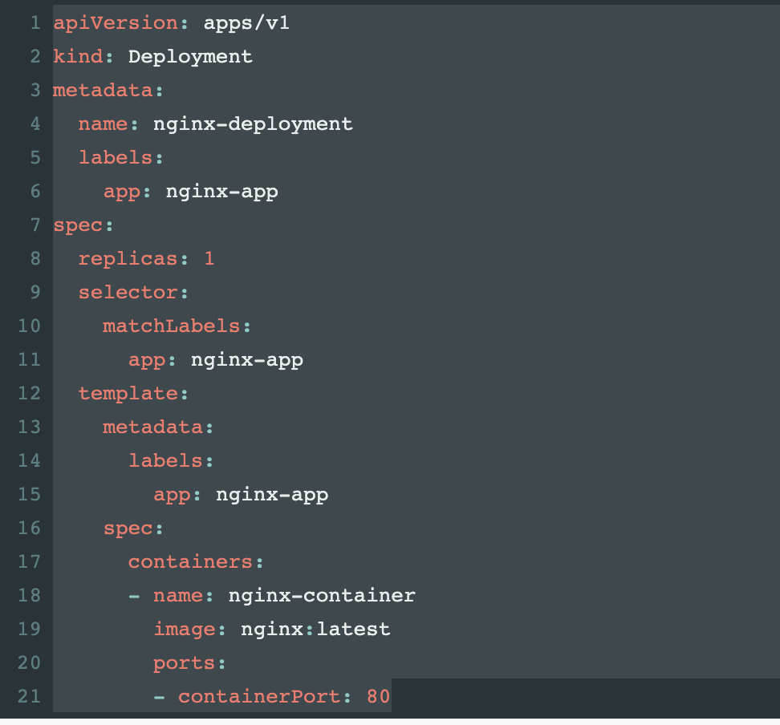

Lets create a pod using kubectl command

kubectl apply -f nginx-deploy.yaml



Lets check Pod status

kubectl get pods



To check Pods all information

kubectl describe pods

To check pods IP address and its states

kubectl get pods -o wide

Expose the Nginx deployment using kubernetes nodeport (32001) service

cat <<EOF | kubectl apply -f -

apiVersion: v1

kind: Service

metadata:

name: nginx-app

spec:

selector:

app: nginx-app

type: NodePort

ports:

- port: 80

targetPort: 80

nodePort: 32001

EOF

Now access the nginx service by using worked node IP and port 32001

To delete pod

kubectl delete pod fosstechnix-web-pod(pod name)

kubectl delete -f fosstechnix-web-pod.yml